QA RETEST REPORT — CYCLE 2
TasteLanka Restaurant Review Portal
Item | Detail
Product / version | Commit eed62c2 "bug fixes" (branch dev) — cycle 1 tested fc1f1cc
Cycle | Cycle 2 — defect retest and full regression, 1 October 2026
Baseline | Test Plan (BB-01…BB-20, DR-01…DR-07, UT-01…UT-10) and the cycle 1 regression suites
Prepared by | Manuja Rajakaruna — every result from actual execution; evidence under testing/cycles/cycle 2/evidence/

Contents
1. Executive Summary
2. Scope of Cycle 2
3. Test Environment
4. Approach and Test Maintenance
5. Test Execution Summary
6. Defect Retest Results
7. Regression Results
8. Functional (Baseline) Results
9. Dry Runs
10. API and Security Results
11. Non-Functional Results
12. New Defects and Observations
13. Requirements Traceability (summary)
14. Test Metrics
15. Evidence Index
16. Outstanding Risks / Issues
17. Final QA Assessment
Appendix A — Retest Evidence (before / after)

1. Executive Summary
All twenty cycle-1 defects were retested on commit eed62c2 and the complete cycle-1 regression pack was re-executed, together with new tests for the changed behaviour. 20 of 20 cycle-1 defects pass their retest and are Closed. One new defect was found: DEF-021 (Medium) — the backend test suite as committed does not compile, so ./mvnw test/package fail at this commit (fixed locally by QA, needs to be committed).
Counted tests: 296 — 284 passed, 1 failed, 10 not executed (usability sessions, no participants), 1 not applicable. Pass rate = passed ÷ (passed + failed) = 99.6% (cycle 1: 62.8%). Baseline: 20/20 BB pass (BB-19 is a partial pass – interface language switching is not implemented; cycle 1: 16/20); 7/7 dry runs pass. Regression: 0 test(s) changed from PASS to FAIL; 91 changed from FAIL to PASS.
Remaining failures are: C2-AUTO-001.

2. Scope of Cycle 2
- Retest of DEF-001…DEF-020 against their original expected results.
- Regression — re-execution of every cycle-1 suite: backend JUnit (existing + QA), Python API/security/data harness (151 original API tests), persistence across restart, moderator scope, performance, Playwright UI/E2E (BB, DR, responsive, accessibility, multilingual).
- New behaviour introduced by the fix commit — tested with new cases: API: TC-API-030…035 (price/spice filters), TC-API-040…046 (problem+json error bodies), TC-MOD-015…021 (rejection reason, audit fields, re-moderation, rating aggregation), TC-REV-021…027 (review deletion and its access rules), TC-ADM-038/039; start-up: TC-SEC-007/008; JUnit: TC-UNIT-JWT-006, TC-UNIT-DOM-006, TC-INT-023…026, TC-INT-042.
- Out of scope (unchanged): FR-11/FR-12 (not implemented), usability sessions (no participants), load testing.

3. Test Environment
Same machine and tools as cycle 1 (Windows 11 10.0.26200, JDK 17.0.12, Maven 3.9.16, Node 22.21.0, MySQL 8.0.45 on port 3307, Edge 154 via Playwright 1.63.0, axe-core 4.13.0, Python 3.9.12). Differences:
- Commit under test eed62c2. The working tree also contained an uncommitted local change to application.yml (datasource defaults → localhost:3307 root/root); it was overridden by DB_URL/DB_USERNAME/DB_PASSWORD in every run and does not affect results.
- Fresh schemas tastelanka_qa_c2 and tastelanka_junit_c2 created from the updated database/schema/001_schema.sql (price-range CHECK, moderated_by/moderated_at) and the seed script.
- Per the updated README a private JWT_SECRET (64 random URL-safe characters, test value in testing/qa.env) was set for the API.
- All cycle-2 outputs written to testing/cycles/cycle 2/ (scripts now require QA_OUT, so cycle 1 evidence cannot be overwritten).

4. Approach and Test Maintenance
Each defect's retest uses the tests that failed in cycle 1 plus targeted new tests; the whole cycle-1 pack is then re-run as regression. Where the fix commit intentionally changed the UI or an API signature, the affected tests were updated (never to hide a product failure). The UI suite was first run unchanged (run 1: 25 passed, 39 failed — evidence evidence/ui/C2-UI-run1-unchanged-specs-*), then with the maintained specs (final run: 63 passed, 1 failed).
Where | Change | Reason
helpers.ts, customer.spec.ts | Password fields located by role name (/^Password/, /^Confirm password/) instead of getByLabel('Password') | Show/Hide toggle added to password fields; the old locator matched two elements (36 of 39 run-1 failures)
admin.spec.ts BB-13, dry-runs.spec.ts DR-06 | Enter a moderation note before Reject; BB-13 also asserts the 'Add a reason' guard first | Rejection reason is now mandatory (DEF-020 fix)
admin.spec.ts TC-ADM-UI-002 | Assert a clear refusal message without the impossible 'remove reviews first' instruction | Retest against DEF-007's expected result ('409 with a workable instruction'); the cycle-1 proxy check for review-delete buttons no longer reflects the fix design
customer.spec.ts TC-UI-013 | Click the Vegan chip as a link; check every Galle result is in Galle | Chips became links; cycle-1 assertion assumed one Galle cafe, but QA data adds 'QA Reviewed Cafe' in Galle
customer.spec.ts TC-UI-006 | After the selector check, choose a restaurant and complete the submission | Retest of DEF-014 – the journey can now be completed
nonfunctional.spec.ts BB-18c | Open the collapsible 'Filters' panel before counting controls | Mobile filters now live in a <details> disclosure
DomainModelTest (JUnit) | Call Review.moderate(status, note, moderator) and assert moderator/time | Production signature changed; committed test no longer compiled (DEF-021)
RequestValidationTest TC-UNIT-VAL-010 (JUnit) | Disabled with reason; result recorded as NOT APPLICABLE | Premise (Bean Validation on the request record) obsolete – fix validates in the controller + DB constraint; behaviour verified by TC-INT-034, TC-ADM-007, TC-ADM-039

5. Test Execution Summary
Level/Type | Total | Passed | Failed | Not executed | Not applicable | Cycle 1 (pass/fail)
API/Security/Data (system) | 183 | 183 | 0 | 0 | 0 | 82/70
JUnit integration | 29 | 29 | 0 | 0 | 0 | 13/11
JUnit unit | 24 | 23 | 0 | 0 | 1 | 21/1
Baseline black-box (UI/E2E) | 20 | 20 | 0 | 0 | 0 | 16/4
Dry run (E2E) | 7 | 7 | 0 | 0 | 0 | 7/0
Performance (UI) | 1 | 1 | 0 | 0 | 0 | 1/0
UI/E2E | 18 | 18 | 0 | 0 | 0 | 12/6
Existing automated/static | 4 | 3 | 1 | 0 | 0 | 3/0
Usability (participant) | 10 | 0 | 0 | 10 | 0 | 0/0

Not counted: 26 setup steps and 4 informational observations (TC-SEC-006, TC-SEC-060, TC-SEC-071/072). Static checks: ESLint, next build and tsc pass; ./mvnw test as committed fails to compile (C2-AUTO-001, DEF-021); after the test update the backend suite runs 76 tests: 75 passed, 1 not applicable (C2-AUTO-002, final run C2-AUTO-003: BUILD SUCCESS).

6. Defect Retest Results
Defect | Sev. | Title | Retest result | Status now
DEF-001 | High | API returns HTTP 403 with empty body instead of the real error status (400/401/404/405/409 | PASS | Closed
DEF-002 | Medium | Unauthenticated requests to protected endpoints return 403 instead of 401 | PASS | Closed
DEF-003 | Critical | Default JWT signing secret committed in application.yml allows forging admin tokens | PASS | Closed
DEF-004 | Medium | Approved reviews never update restaurant/dish rating or review count | PASS | Closed
DEF-005 | Low | Restaurant accepted with minimum price greater than maximum price | PASS | Closed
DEF-006 | Medium | Updating a restaurant or dish to an existing slug causes an unhandled server exception | PASS | Closed
DEF-007 | Medium | Restaurants that have reviews cannot be deleted; UI instructs an impossible action | PASS | Closed
DEF-008 | High | Admin edits to seeded data are overwritten, and deleted seeded dishes are re-created, on e | PASS | Closed
DEF-009 | Medium | Cuisine category links do not filter the restaurant list | PASS | Closed
DEF-010 | Medium | Price and spice-level filters are not available; home page filter chips and location selec | PASS | Closed
DEF-011 | Low | 'Clear all' unticks filters but results stay filtered until 'Apply Filters' is pressed | PASS | Closed
DEF-012 | Medium | No search filters available on mobile | PASS | Closed
DEF-013 | Medium | Restaurant listing overflows horizontally and collapses at tablet width (768 px) | PASS | Closed
DEF-014 | Medium | 'Write a Review' from the home page is a dead end (no restaurant can be selected) | PASS | Closed
DEF-015 | Low | Restaurant page shows 'Save' for a restaurant the user has already saved | PASS | Closed
DEF-016 | Low | Home page 'Top Rated' cards and cuisine counts are hard-coded and disagree with live data | PASS | Closed
DEF-017 | Medium | Insufficient colour contrast of brand-orange text (WCAG 1.4.3) | PASS | Closed
DEF-018 | Medium | Search input and select boxes on /restaurants have no accessible label | PASS | Closed
DEF-019 | Medium | Rating star buttons are announced only as '★' with no value or selected state | PASS | Closed
DEF-020 | Medium | Moderation actions are not traceable (no moderator, timestamp or reason captured) | PASS | Closed
DEF-021 | Medium | Backend test suite does not compile at commit eed62c2 (DomainModelTest uses the old Review | PASS (pending commit) | Fixed

Per-defect retest test IDs, statuses and evidence: retest-results.csv. The live register testing/defects/defect-register.csv has been updated (Status, Fix Version, Retest Result); the pre-retest copy is defect-register-before-retest.csv.

7. Regression Results
Comparison of every counted test with its cycle-1 status (regression-comparison.csv): FAIL→PASS: 91, unchanged PASS: 155, new: 39, other: 11.
No test that passed in cycle 1 fails in cycle 2.

8. Functional (Baseline) Results
Test ID | Requirement | Cycle 1 | Cycle 2 | Defect
BB-01 | FR-06 | PASS | PASS
BB-02 | FR-06, FR-17 | PASS | PASS
BB-03 | FR-07 | PASS | PASS
BB-04 | FR-07 | PASS | PASS
BB-05 | FR-08 | PASS | PASS
BB-06 | FR-01 | PASS | PASS
BB-07 | FR-04 | PASS | PASS
BB-08 | FR-05 | FAIL | PASS
BB-09 | FR-02, FR-03 | PASS | PASS
BB-10 | FR-09 | PASS | PASS
BB-11 | FR-09, FR-17 | PASS | PASS
BB-12 | FR-10 | PASS | PASS
BB-13 | FR-14 | PASS | PASS
BB-14 | FR-16 | PASS | PASS
BB-15 | FR-13 | PASS | PASS
BB-16 | FR-13 | PASS | PASS
BB-17 | FR-18 | FAIL | PASS
BB-18 | NFR-04 | FAIL | PASS
BB-19 | FR-15 | PASS (partial – UI translation not implemented) | PASS (partial – UI translation not implemented)
BB-20 | NFR-03 | FAIL | PASS

9. Dry Runs
Test ID | Cycle 1 | Cycle 2 | Notes
DR-01 | PASS | PASS | Completed – see step log
DR-02 | PASS | PASS | Completed – see step log
DR-03 | PASS | PASS | Completed – see step log
DR-04 | PASS | PASS | Completed – see step log
DR-05 | PASS | PASS | Completed – see step log
DR-06 | PASS | PASS | Completed – see step log
DR-07 | PASS | PASS | Completed – see step log

10. API and Security Results
- Original API/security suite: 152 passed / 0 failed (cycle 1: 82 / 70).
- Errors now return the correct status with an RFC 7807 application/problem+json body (e.g. 400 fullName: must not be blank, 409 Restaurant has customer reviews and cannot be deleted); unauthenticated requests get 401.
- Token forged with the old default secret: PASS (rejected). API start-up without JWT_SECRET: PASS; with the .env.example placeholder: PASS.
- Review deletion: author only (another customer 403, admin token 403, anonymous 401, missing 404); deleting an approved review updates the rating.
- Observations unchanged from cycle 1 (not defects): no login throttling after 10 failures (TC-SEC-060); a JWT stays valid until expiry after logout (TC-SEC-006); MODERATOR can create/delete restaurants (TC-SEC-071/072).

11. Non-Functional Results
Performance (NFR-01) — measured only (no thresholds defined):
ID | Operation | Cycle 1 median ms | Cycle 2 median ms | Cycle 1 p95 | Cycle 2 p95
PERF-001 | Restaurant listing | 10.8 | 13.1 | 13.2 | 16.1
PERF-002 | Search q=crab | 9.6 | 10.5 | 10.8 | 11.9
PERF-003 | Filter location=Kandy&vegan=true | 8.7 | 9.7 | 9.7 | 11.7
PERF-004 | Top-rated | 8.6 | 9.0 | 10.0 | 11.2
PERF-005 | Restaurant details | 8.1 | 8.8 | 10.3 | 10.8
PERF-006 | Restaurant menu (dishes) | 9.5 | 10.8 | 11.3 | 11.7
PERF-007 | Public approved reviews | 10.3 | 12.0 | 11.9 | 14.9
PERF-008 | Own reviews (auth) | 12.0 | 13.4 | 13.6 | 14.8
PERF-009 | Profile (auth) | 8.9 | 10.8 | 10.5 | 11.9
PERF-010 | Login (bcrypt) | 96.6 | 103.9 | 99.4 | 110.2
PERF-011 | Submit review (auth, write) | 15.9 | 22.0 | 22.0 | 23.1

Median change per operation: +0.4 to +7.3 ms (single client, local; indicative). The listing query now also evaluates the spice-level sub-query.
Responsiveness — mobile PASS, tablet PASS (cycle 1 FAIL, 153 px overflow), desktop PASS; mobile filters PASS.
Accessibility — axe WCAG 2.1 A/AA PASS; star buttons PASS; form labels PASS; keyboard login PASS; focus PASS. Observation: the password input's accessible name is now "Password Show password" because the new toggle button sits inside the label (minor; not logged as a defect).
Multilingual — Sinhala/Tamil content PASS/PASS; UI language switch FAIL (not implemented – change-management item, as in cycle 1).

12. New Defects and Observations
- DEF-021 (Medium / High priority) — backend test sources do not compile at eed62c2; QA updated DomainModelTest in the working tree (uncommitted). Status Fixed, to be closed once committed and the build passes on the committed code.
- Observation — seeded restaurants keep their demo rating/review counts and approved reviews are added on top (e.g. Ministry of Crab 320 → 322); expected for demo seed data, but the seeded numbers are not real reviews.
- Observation — password-field accessible name (see §11).
- Observation — at 768 px (tablet portrait) the header logo text "TasteLanka" touches the "Home" link (no overflow; cosmetic, also visible in cycle 1) — see the cycle-2 tablet figure in Appendix A.3.

13. Requirements Traceability (summary)
Requirement | Purpose | Execution Status | Result | Coverage Status
FR-01 | Restaurant browsing | 5/5 executed | PASS | Covered
FR-02 | Restaurant details | 4/4 executed | PASS | Covered
FR-03 | Menu/dish information | 4/4 executed | PASS | Covered
FR-04 | Restaurant search | 7/7 executed | PASS | Covered
FR-05 | Restaurant filtering | 10/10 executed | PASS | Covered
FR-06 | User registration | 9/9 executed | PASS | Covered
FR-07 | User authentication | 7/7 executed | PASS | Covered
FR-08 | User profile | 5/5 executed | PASS | Covered
FR-09 | Ratings and reviews | 9/9 executed | PASS | Covered
FR-10 | Own review management/viewing | 6/6 executed | PASS | Covered
FR-11 | Review comments | — | — | Not Implemented
FR-12 | Restaurant responses | — | — | Not Implemented
FR-13 | Restaurant/menu management | 11/11 executed | PASS | Covered
FR-14 | Review moderation | 7/7 executed | PASS | Covered
FR-15 | Multilingual content | 6/6 executed | PASS | Partially Covered
FR-16 | Role-based access | 9/9 executed | PASS | Covered
FR-17 | Validation/error handling | 8/8 executed | PASS | Covered
FR-18 | Data persistence | 7/7 executed | PASS | Covered
NFR-01 | Performance of common actions | Executed (PERF-001..011, PERF-UI) | MEASURED | Partially Covered
NFR-02 | Usability | 0/10 executed | NOT EXECUTED | Not Evidenced
NFR-03 | Accessibility | 1/1 executed | PASS | Covered
NFR-04 | Responsiveness | 1/1 executed | PASS | Covered
NFR-05 | Security/access control | 11/11 executed | PASS | Covered
NFR-06 | Privacy/data handling | 6/6 executed | PASS | Covered
NFR-07 | Data integrity | 5/5 executed | PASS | Covered
NFR-08 | Error handling/reliability | 7/7 executed | PASS | Covered
NFR-12 | Testability | Assessed | FAIL | Partially Covered
NFR-13 | Administrative/moderation traceability | 5/5 executed | PASS | Covered

Full matrix (test IDs, evidence, defects): traceability-matrix.csv.

14. Test Metrics
See test-metrics.md. Retest pass rate: 21/21 defects (100.0%). Defects: Fixed 1, Closed 20; open by severity: Medium 1.

15. Evidence Index
355 cycle-2 evidence items catalogued as C2-EVID-001…C2-EVID-355 in evidence-index.csv. Appendix A shows the key before/after evidence; cycle-1 items keep their cycle-1 IDs (EVID-nnn, testing/cycles/cycle 1/evidence-index.csv).

16. Outstanding Risks / Issues
- DEF-021 must be committed, otherwise CI and packaging fail on the dev branch.
- No reopened defects.
- Not implemented: FR-11 review comments, FR-12 restaurant responses, interface language switching (FR-15 partial).
- Unchanged observations: no login throttling, JWT not revocable on logout, MODERATOR has full catalogue rights.
- Usability (NFR-02) still unevidenced — UT-01…UT-10 need participants.
- testing/qa.env holds local test credentials and the test JWT secret and is tracked by git; keep it out of shared repositories.

17. Final QA Assessment
Based on executed tests, the fix commit resolves the defects listed as Closed above, including the Critical token-forgery issue (DEF-003) and both High defects (DEF-001, DEF-008), and introduced no regression in previously passing tests. Before the build can be accepted, DEF-021 must be committed (the committed code does not pass ./mvnw test). FR-11, FR-12 and UI translation remain not implemented, and usability testing with participants is still outstanding.

Appendix A — Retest Evidence (before / after)
Cycle 1 items are from testing/cycles/evidence/ (IDs EVID-nnn); cycle 2 items from testing/cycles/cycle 2/evidence/ (IDs C2-EVID-nnn). Screenshots are downscaled copies; very tall pages are cropped to the top.

A.1 API and security (same test, cycle 1 vs cycle 2)
DEF-001 — TC-AUTH-003
Cycle 1 · EVID-062 · TC-AUTH-003 — Register with empty body (missing all fields) · verdict FAIL
POST http://localhost:8080/api/v1/auth/register
Authorization: none
Request body: {}
→ HTTP 403 Content-Type: -
Response body: (empty)
Expected: HTTP 400 with validation feedback
Actual: HTTP 403
Cycle 2 · C2-EVID-075 · TC-AUTH-003 — Register with empty body (missing all fields) · verdict PASS
POST http://localhost:8080/api/v1/auth/register
Authorization: none
Request body: {}
→ HTTP 400 Content-Type: application/problem+json
Response body: {"detail": "email: must not be blank", "instance": "/api/v1/auth/register", "status": 400, "title": "Bad Request"}
Expected: HTTP 400 with validation feedback
Actual: HTTP 400
DEF-001 — TC-ADM-003
Cycle 1 · EVID-005 · TC-ADM-003 — Create restaurant with duplicate slug · verdict FAIL
POST http://localhost:8080/api/v1/admin/restaurants
Authorization: Bearer <ADMIN token>
Request body: {"slug": "qa-rest-190512", "name": "QA Test Bistro", "cuisine": "Sri Lankan · Fusion", "location": "Galle", "priceMin": 1000, "priceMax": 2500, "vegetarian": true, "vegan": false, "halal": true, "description": "Created b …(truncated)
→ HTTP 403 Content-Type: -
Response body: (empty)
Expected: HTTP 409
Actual: HTTP 403
Cycle 2 · C2-EVID-005 · TC-ADM-003 — Create restaurant with duplicate slug · verdict PASS
POST http://localhost:8080/api/v1/admin/restaurants
Authorization: Bearer <ADMIN token>
Request body: {"slug": "qa-rest-112400", "name": "QA Test Bistro", "cuisine": "Sri Lankan · Fusion", "location": "Galle", "priceMin": 1000, "priceMax": 2500, "vegetarian": true, "vegan": false, "halal": true, "description": "Created b …(truncated)
→ HTTP 409 Content-Type: application/problem+json
Response body: {"detail": "Restaurant slug already exists", "instance": "/api/v1/admin/restaurants", "status": 409, "title": "Conflict"}
Expected: HTTP 409
Actual: HTTP 409
DEF-002 — TC-SEC-001
Cycle 1 · EVID-203 · TC-SEC-001 — Protected endpoint without token (/users/me) · verdict FAIL
GET http://localhost:8080/api/v1/users/me
Authorization: none
→ HTTP 403 Content-Type: -
Response body: (empty)
Expected: HTTP 401 Unauthorized
Actual: HTTP 403
Cycle 2 · C2-EVID-237 · TC-SEC-001 — Protected endpoint without token (/users/me) · verdict PASS
GET http://localhost:8080/api/v1/users/me
Authorization: none
→ HTTP 401 Content-Type: application/problem+json;charset=ISO-8859-1
Response body: {"status": 401, "detail": "Authentication is required"}
Expected: HTTP 401 Unauthorized
Actual: HTTP 401
DEF-003 — TC-SEC-005
Cycle 1 · EVID-207 · TC-SEC-005 — Forged admin token signed with default JWT secret (JWT_SECRET not set, as in README run steps) · verdict FAIL
GET http://localhost:8080/api/v1/admin/dashboard
Authorization: Bearer <token forged offline with the default JWT secret from application.yml>
→ HTTP 200 Content-Type: application/json
Response body: {"restaurants": 7, "dishes": 4, "users": 8, "pendingReviews": 3, "approvedReviews": 4}
Expected: HTTP 401/403 – tokens not issued by the server must be rejected
Actual: HTTP 200
Cycle 2 · C2-EVID-241 · TC-SEC-005 — Forged admin token signed with default JWT secret (JWT_SECRET not set, as in README run steps) · verdict PASS
GET http://localhost:8080/api/v1/admin/dashboard
Authorization: Bearer <token forged offline with the default JWT secret from application.yml>
→ HTTP 401 Content-Type: application/problem+json;charset=ISO-8859-1
Response body: {"status": 401, "detail": "Authentication is required"}
Expected: HTTP 401/403 – tokens not issued by the server must be rejected
Actual: HTTP 401
DEF-004 — TC-MOD-012
Cycle 1 · EVID-090 · TC-MOD-012 — Approved review is reflected in restaurant reviewCount/rating · verdict FAIL
GET http://localhost:8080/api/v1/restaurants/ministry-of-crab
Authorization: none
→ HTTP 200 Content-Type: application/json
Response body: {"id": 1, "slug": "ministry-of-crab", "name": "Ministry of Crab", "cuisine": "Seafood · Sri Lankan", "location": "Colombo", "rating": 4.8, "reviewCount": 320, "priceMin": 8000, "priceMax": 12000, "vegetarian": false, "vegan": false, "halal": true, "description": "Popular seafood dining in Colombo. B …(truncated)
Expected: HTTP 200; reviewCount increases by 1 and rating is recalculated after approval
Actual: HTTP 200; reviewCount before=320 after=320; rating before=4.8 after=4.8
Cycle 2 · C2-EVID-113 · TC-MOD-012 — Approved review is reflected in restaurant reviewCount/rating · verdict PASS
GET http://localhost:8080/api/v1/restaurants/ministry-of-crab
Authorization: none
→ HTTP 200 Content-Type: application/json
Response body: {"id": 1, "slug": "ministry-of-crab", "name": "Ministry of Crab", "cuisine": "Seafood · Sri Lankan", "location": "Colombo", "rating": 4.8, "reviewCount": 321, "priceMin": 8000, "priceMax": 12000, "vegetarian": false, "vegan": false, "halal": true, "description": "Popular seafood dining in Colombo. B …(truncated)
Expected: HTTP 200; reviewCount increases by 1 and rating is recalculated after approval
Actual: HTTP 200; reviewCount before=320 after=321; rating before=4.8 after=4.8
DEF-005 — TC-ADM-007
Cycle 1 · EVID-009 · TC-ADM-007 — Create restaurant with priceMin > priceMax · verdict FAIL
POST http://localhost:8080/api/v1/admin/restaurants
Authorization: Bearer <ADMIN token>
Request body: {"slug": "qa-inverted-190512", "name": "QA Test Bistro", "cuisine": "Sri Lankan · Fusion", "location": "Galle", "priceMin": 9000, "priceMax": 100, "vegetarian": true, "vegan": false, "halal": true, "description": "Create …(truncated)
→ HTTP 201 Content-Type: application/json
Response body: {"id": 7, "slug": "qa-inverted-190512", "name": "QA Test Bistro", "cuisine": "Sri Lankan · Fusion", "location": "Galle", "rating": 0, "reviewCount": 0, "priceMin": 9000, "priceMax": 100, "vegetarian": true, "vegan": false, "halal": true, "description": "Created by QA API test.", "imageColor": "#1234 …(truncated)
Expected: HTTP 400 (minimum price must not exceed maximum price)
Actual: HTTP 201
Cycle 2 · C2-EVID-009 · TC-ADM-007 — Create restaurant with priceMin > priceMax · verdict PASS
POST http://localhost:8080/api/v1/admin/restaurants
Authorization: Bearer <ADMIN token>
Request body: {"slug": "qa-inverted-112400", "name": "QA Test Bistro", "cuisine": "Sri Lankan · Fusion", "location": "Galle", "priceMin": 9000, "priceMax": 100, "vegetarian": true, "vegan": false, "halal": true, "description": "Create …(truncated)
→ HTTP 400 Content-Type: application/problem+json
Response body: {"detail": "Minimum price must not exceed maximum price", "instance": "/api/v1/admin/restaurants", "status": 400, "title": "Bad Request"}
Expected: HTTP 400 (minimum price must not exceed maximum price)
Actual: HTTP 400
DEF-006 — TC-ADM-011
Cycle 1 · EVID-013 · TC-ADM-011 — Update restaurant to slug already used by another restaurant · verdict FAIL
PUT http://localhost:8080/api/v1/admin/restaurants/6
Authorization: Bearer <ADMIN token>
Request body: {"slug": "nuga-gama", "name": "QA Test Bistro", "cuisine": "Sri Lankan · Fusion", "location": "Galle", "priceMin": 1000, "priceMax": 2500, "vegetarian": true, "vegan": false, "halal": true, "description": "Created by QA …(truncated)
→ HTTP 403 Content-Type: -
Response body: (empty)
Expected: HTTP 409 Conflict (slug already exists)
Actual: HTTP 403
Cycle 2 · C2-EVID-013 · TC-ADM-011 — Update restaurant to slug already used by another restaurant · verdict PASS
PUT http://localhost:8080/api/v1/admin/restaurants/6
Authorization: Bearer <ADMIN token>
Request body: {"slug": "nuga-gama", "name": "QA Test Bistro", "cuisine": "Sri Lankan · Fusion", "location": "Galle", "priceMin": 1000, "priceMax": 2500, "vegetarian": true, "vegan": false, "halal": true, "description": "Created by QA …(truncated)
→ HTTP 409 Content-Type: application/problem+json
Response body: {"detail": "Restaurant slug already exists", "instance": "/api/v1/admin/restaurants/6", "status": 409, "title": "Conflict"}
Expected: HTTP 409 Conflict (slug already exists)
Actual: HTTP 409
DEF-007 — TC-ADM-037
Cycle 1 · EVID-036 · TC-ADM-037 — Delete restaurant that has customer reviews · verdict FAIL
DELETE http://localhost:8080/api/v1/admin/restaurants/8
Authorization: Bearer <ADMIN token>
→ HTTP 403 Content-Type: -
Response body: (empty)
Expected: HTTP 204 (restaurant and dependent data removed) or HTTP 409 with an explanatory message; never a 5xx
Actual: HTTP 403
Cycle 2 · C2-EVID-036 · TC-ADM-037 — Delete restaurant that has customer reviews · verdict PASS
DELETE http://localhost:8080/api/v1/admin/restaurants/7
Authorization: Bearer <ADMIN token>
→ HTTP 409 Content-Type: application/problem+json
Response body: {"detail": "Restaurant has customer reviews and cannot be deleted", "instance": "/api/v1/admin/restaurants/7", "status": 409, "title": "Conflict"}
Expected: HTTP 204 (restaurant and dependent data removed) or HTTP 409 with an explanatory message; never a 5xx
Actual: HTTP 409
DEF-008 — TC-DATA-002
Cycle 1 · EVID-154 · TC-DATA-002 — Admin edit to seeded restaurant survives restart · verdict FAIL
GET http://localhost:8080/api/v1/restaurants/nuga-gama
Authorization: none
→ HTTP 200 Content-Type: application/json
Response body: {"id": 4, "slug": "nuga-gama", "name": "Nuga Gama", "cuisine": "Sri Lankan · Authentic", "location": "Colombo", "rating": 4.4, "reviewCount": 150, "priceMin": 3000, "priceMax": 5000, "vegetarian": true, "vegan": true, "halal": true, "description": "Traditional Sri Lankan dining with local cuisine op …(truncated)
Expected: HTTP 200; description='QA-EDITED description 190512', priceMin=3500
Actual: HTTP 200; description after restart='Traditional Sri Lankan dining with local cuisine options.'; priceMin=3000
Cycle 2 · C2-EVID-187 · TC-DATA-002 — Admin edit to seeded restaurant survives restart · verdict PASS
GET http://localhost:8080/api/v1/restaurants/nuga-gama
Authorization: none
→ HTTP 200 Content-Type: application/json
Response body: {"id": 4, "slug": "nuga-gama", "name": "Nuga Gama", "cuisine": "Sri Lankan · Authentic", "location": "Colombo", "rating": 4.4, "reviewCount": 152, "priceMin": 3500, "priceMax": 5000, "vegetarian": true, "vegan": true, "halal": true, "description": "QA-EDITED description 112400", "imageColor": "#662e …(truncated)
Expected: HTTP 200; description='QA-EDITED description 112400', priceMin=3500
Actual: HTTP 200; description after restart='QA-EDITED description 112400'; priceMin=3500

A.2 New tests for the fixes
Cycle 2 · C2-EVID-062 · TC-API-030 — Filter maxPrice=2000 returns only restaurants starting at or below LKR 2,000 · verdict PASS
GET http://localhost:8080/api/v1/restaurants?maxPrice=2000
Authorization: none
→ HTTP 200 Content-Type: application/json
Response body: [{"id": 2, "slug": "the-empire-cafe", "name": "The Empire Cafe", "cuisine": "Cafe · International", "location": "Kandy", "rating": 4.6, "reviewCount": 220, "priceMin": 2000, "priceMax": 4000, "vegetarian": true, "vegan": true, "halal": true, "description": "Casual dining with local and international …(truncated)
Expected: HTTP 200
Actual: HTTP 200; slugs=['green-leaf-kitchen', 'qa-rest2-112400', 'the-empire-cafe']
Cycle 2 · C2-EVID-063 · TC-API-031 — Filter spiceLevel=Hot returns restaurants with a Hot dish · verdict PASS
GET http://localhost:8080/api/v1/restaurants?spiceLevel=Hot
Authorization: none
→ HTTP 200 Content-Type: application/json
Response body: [{"id": 1, "slug": "ministry-of-crab", "name": "Ministry of Crab", "cuisine": "Seafood · Sri Lankan", "location": "Colombo", "rating": 4.8, "reviewCount": 322, "priceMin": 8000, "priceMax": 12000, "vegetarian": false, "vegan": false, "halal": true, "description": "Popular seafood dining in Colombo. …(truncated)
Expected: HTTP 200
Actual: HTTP 200; slugs=['ministry-of-crab']
Cycle 2 · C2-EVID-118 · TC-MOD-015 — Reject without a reason is refused · verdict PASS
PATCH http://localhost:8080/api/v1/admin/reviews/9
Authorization: Bearer <ADMIN token>
Request body: {"status": "REJECTED"}
→ HTTP 400 Content-Type: application/problem+json
Response body: {"detail": "A rejection reason is required", "instance": "/api/v1/admin/reviews/9", "status": 400, "title": "Bad Request"}
Expected: HTTP 400
Actual: HTTP 400; Content-Type=application/problem+json; detail='A rejection reason is required'
Cycle 2 · C2-EVID-121 · TC-MOD-018 — Reject with reason records moderator, time and note · verdict PASS
PATCH http://localhost:8080/api/v1/admin/reviews/9
Authorization: Bearer <ADMIN token>
Request body: {"status": "REJECTED", "note": "Duplicate content"}
→ HTTP 200 Content-Type: application/json
Response body: {"id": 9, "author": "QA User A", "restaurantSlug": "nuga-gama", "restaurantName": "Nuga Gama", "foodRating": 4, "serviceRating": 4, "overallRating": 4, "language": "en", "reviewText": "Cycle 2 QA review for retest.", "status": "REJECTED", "moderatorNote": "Duplicate content", "moderatedBy": "TasteLa …(truncated)
Expected: HTTP 200
Actual: HTTP 200; note='Duplicate content' moderatedBy='TasteLanka Admin' moderatedAt='2026-10-01T05:54:19.562502900Z'
Cycle 2 · C2-EVID-124 · TC-MOD-021 — Rejecting a previously approved review removes it from the rating · verdict PASS
GET http://localhost:8080/api/v1/restaurants/qa-agg-112400c2
Authorization: none
→ HTTP 200 Content-Type: application/json
Response body: {"id": 8, "slug": "qa-agg-112400c2", "name": "QA Aggregation Cafe", "cuisine": "Sri Lankan", "location": "Kandy", "rating": 4.0, "reviewCount": 1, "priceMin": 500, "priceMax": 900, "vegetarian": true, "vegan": false, "halal": false, "imageColor": "#332417"}
Expected: HTTP 200
Actual: HTTP 200; rating=4.0 count=1
Cycle 2 · C2-EVID-143 · TC-REV-021 — Author deletes own approved review · verdict PASS
DELETE http://localhost:8080/api/v1/reviews/10
Authorization: Bearer <USER_B token>
→ HTTP 204 Content-Type: -
Response body: (empty)
Expected: HTTP 204
Actual: HTTP 204
Cycle 2 · C2-EVID-233 · TC-REV-022 — Another user cannot delete someone else's review · verdict PASS
DELETE http://localhost:8080/api/v1/reviews/10
Authorization: Bearer <USER_A token>
→ HTTP 403 Content-Type: application/problem+json
Response body: {"detail": "You can only delete your own reviews", "instance": "/api/v1/reviews/10", "status": 403, "title": "Forbidden"}
Expected: HTTP 403
Actual: HTTP 403; Content-Type=application/problem+json; detail='You can only delete your own reviews'
Cycle 2 · C2-EVID-068 · TC-API-040 — Invalid registration returns 400 with problem detail · verdict PASS
POST http://localhost:8080/api/v1/auth/register
Authorization: none
Request body: {}
→ HTTP 400 Content-Type: application/problem+json
Response body: {"detail": "fullName: must not be blank", "instance": "/api/v1/auth/register", "status": 400, "title": "Bad Request"}
Expected: HTTP 400, Content-Type application/problem+json, non-empty 'detail'
Actual: HTTP 400; Content-Type=application/problem+json; detail='fullName: must not be blank'
C2-EVID-243 · TC-SEC-007 — API start-up without JWT_SECRET (DEF-003)
Caused by: org.springframework.util.PlaceholderResolutionException: Could not resolve placeholder 'JWT_SECRET' in value "${JWT_SECRET}" <-- "${app.jwt.secret}"
[INFO] BUILD FAILURE
exit=1
C2-EVID-244 · TC-SEC-008 — start-up with the .env.example placeholder (DEF-003)
Caused by: java.lang.IllegalStateException: JWT_SECRET must be set to a private value of at least 32 bytes
[INFO] BUILD FAILURE
exit=1
C2-EVID-155 · C2-AUTO-001 — ./mvnw test as committed (DEF-021)
[ERROR] COMPILATION ERROR :
[ERROR] /D:/restaurent/restaurant-review-portal/backend/src/test/java/com/tastelanka/portal/qa/DomainModelTest.java:[60,15] method moderate in class com.tastelanka.portal.review.Review cannot be appli
[INFO] BUILD FAILURE
[ERROR] /D:/restaurent/restaurant-review-portal/backend/src/test/java/com/tastelanka/portal/qa/DomainModelTest.java:[60,15] method moderate in class com.tastelanka.portal.review.Review cannot be appli
exit=1 elapsed=34s
C2-EVID-156 · C2-AUTO-002 — backend suite after test update
[INFO] Tests run: 1, Failures: 0, Errors: 0, Skipped: 0, Time elapsed: 15.30 s -- in com.tastelanka.portal.BackendApplicationTests
[INFO] Tests run: 23, Failures: 0, Errors: 0, Skipped: 0, Time elapsed: 8.146 s -- in com.tastelanka.portal.qa.ApiIntegrationTest
[INFO] Tests run: 6, Failures: 0, Errors: 0, Skipped: 0, Time elapsed: 0.013 s -- in com.tastelanka.portal.qa.DomainModelTest
[INFO] Tests run: 5, Failures: 0, Errors: 0, Skipped: 0, Time elapsed: 2.311 s -- in com.tastelanka.portal.qa.HttpErrorContractTest
[INFO] Tests run: 6, Failures: 0, Errors: 0, Skipped: 0, Time elapsed: 0.032 s -- in com.tastelanka.portal.qa.JwtServiceTest
[ERROR] Tests run: 35, Failures: 1, Errors: 0, Skipped: 0, Time elapsed: 0.287 s <<< FAILURE! -- in com.tastelanka.portal.qa.RequestValidationTest
[ERROR] Tests run: 76, Failures: 1, Errors: 0, Skipped: 0
EVID-166 · Cycle 1 — database after API restart (DEF-008: edit reverted, deleted dish re-created)
| snapshot_time |
| 4 | nuga-gama | 3000 | Traditional Sri Lankan dining with local cuis |
| 10 | seafood-kottu | 1 |
C2-EVID-199 · Cycle 2 — database after API restart (edit kept, deleted dish stays deleted)
| snapshot_time |
| 4 | nuga-gama | 3500 | QA-EDITED description 112400 |
C2-EVID-198 · Cycle 2 — integrity and moderation-audit checks (DEF-005, DEF-020)
| reviews without user | 0 |
| reviews without restaurant | 0 |
| reviews whose dish belongs to other restaurant | 0 |
| dishes without restaurant | 0 |
| saved rows without user/restaurant | 0 |
| duplicate saved rows | 0 |
| ratings outside 1-5 | 0 |
| restaurants priceMin>priceMax | 0 |
| moderated reviews missing moderator/time | 0 |
| rejected reviews without reason | 0 |
| id | status | moderator_note | moderated_by | moderated_at |
| 6 | REJECTED | QA rejected | qa.admin@tastelanka.test | 2026-10-01 05:54:03.586565 |
| 9 | REJECTED | Duplicate content | qa.admin@tastelanka.test | 2026-10-01 05:54:19.562503 |
| 11 | REJECTED | Re-moderated by QA | qa.admin@tastelanka.test | 2026-10-01 05:54:19.797333 |
| ministry-of-crab | 4.8 | 322 | 2 |
| the-empire-cafe | 4.6 | 220 | 0 |

A.3 UI (cycle 1 vs cycle 2)
DEF-009 — cuisine link Seafood
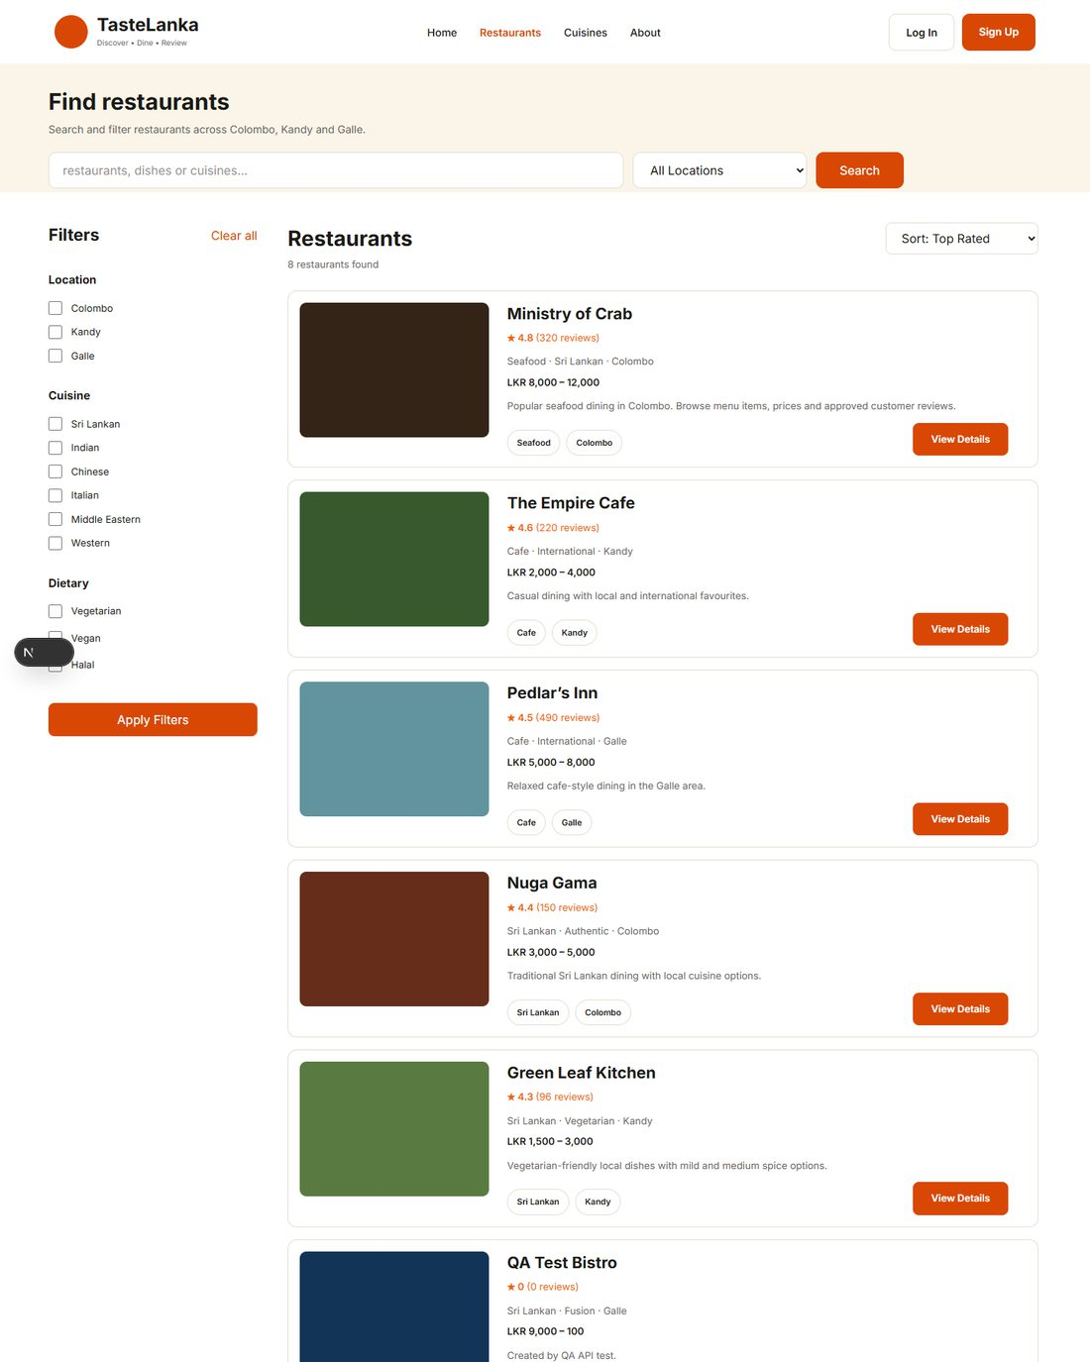
Cycle 1 · EVID-250 · DEF-009 — cuisine link Seafood — source: cycles/evidence/ui/BB-08c-cuisine-link-seafood.png (top of page shown)
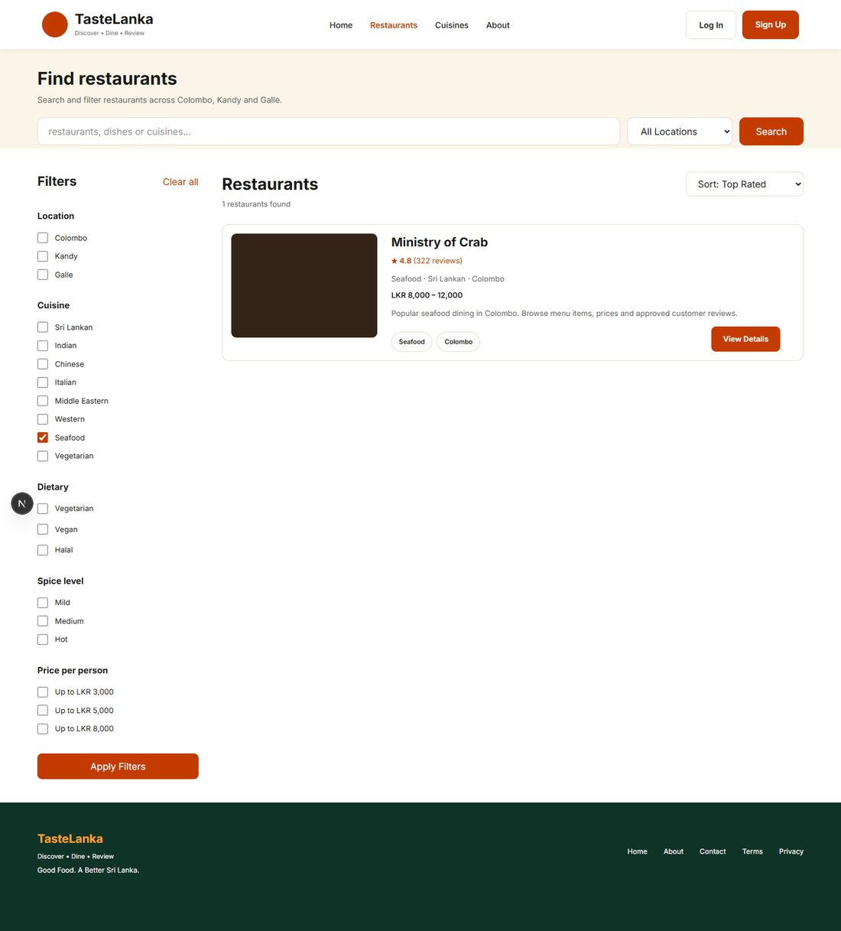
Cycle 2 · C2-EVID-286 · DEF-009 — cuisine link Seafood — source: cycle 2/evidence/ui/BB-08c-cuisine-link-seafood.png
DEF-014 — review from the home page
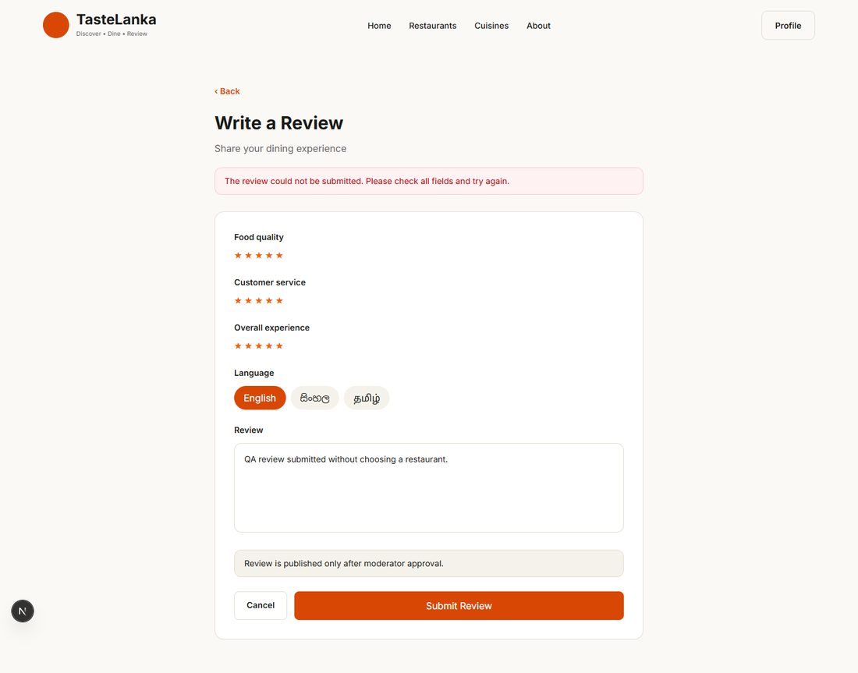
Cycle 1 · EVID-277 · DEF-014 — review from the home page — source: cycles/evidence/ui/TC-UI-006-review-without-restaurant.png
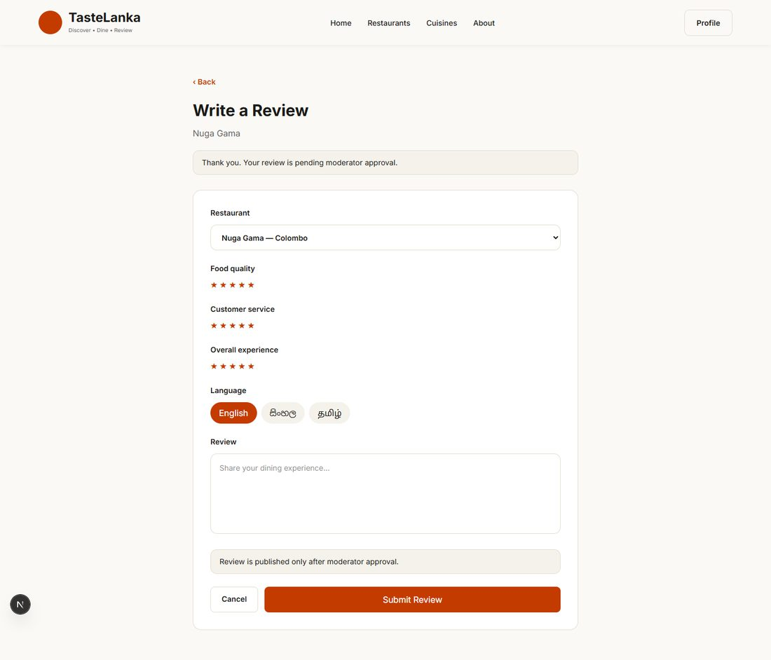
Cycle 2 · C2-EVID-319 · DEF-014 — review from the home page — source: cycle 2/evidence/ui/TC-UI-006-review-without-restaurant.png
DEF-013 — restaurant list at 768 px
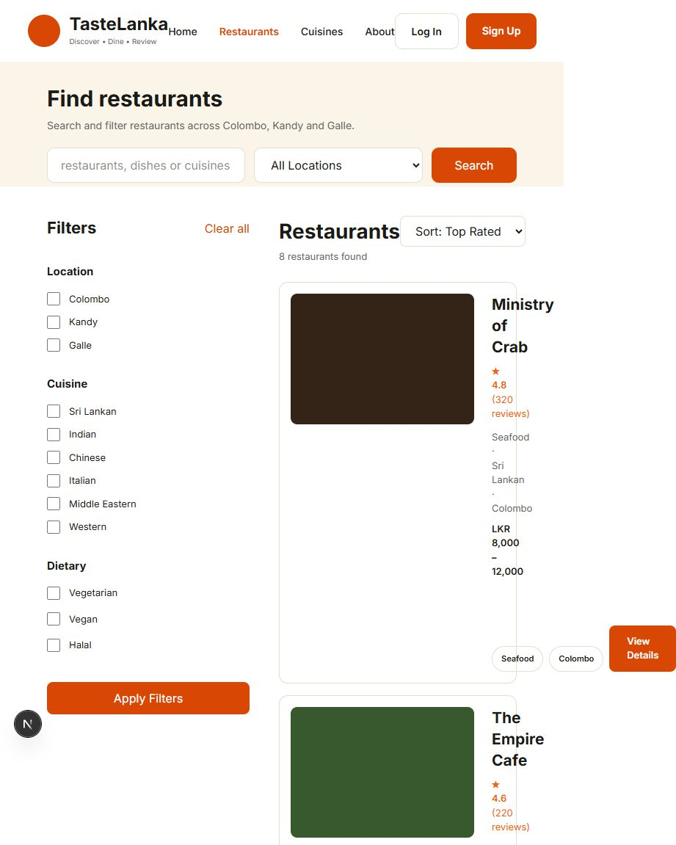
Cycle 1 · EVID-321 · DEF-013 — restaurant list at 768 px — source: cycles/evidence/ui/responsive/BB-18-tablet-restaurants.png (top of page shown)
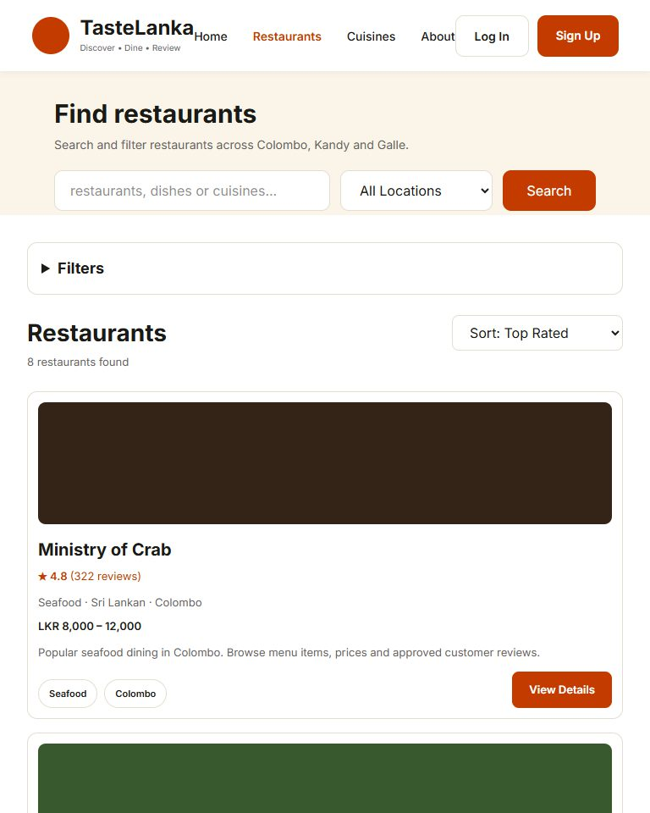
Cycle 2 · C2-EVID-349 · DEF-013 — restaurant list at 768 px — source: cycle 2/evidence/ui/responsive/BB-18-tablet-restaurants.png (top of page shown)
DEF-012 — filters on a phone
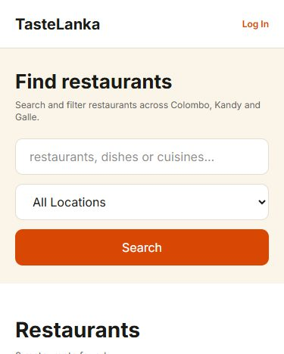
Cycle 1 · EVID-323 · DEF-012 — filters on a phone — source: cycles/evidence/ui/responsive/BB-18c-mobile-restaurants-no-filters.png (top of page shown)
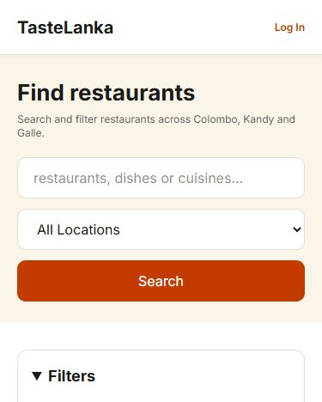
Cycle 2 · C2-EVID-351 · DEF-012 — filters on a phone — source: cycle 2/evidence/ui/responsive/BB-18c-mobile-restaurants-no-filters.png (top of page shown)
DEF-015 — saved state after reload
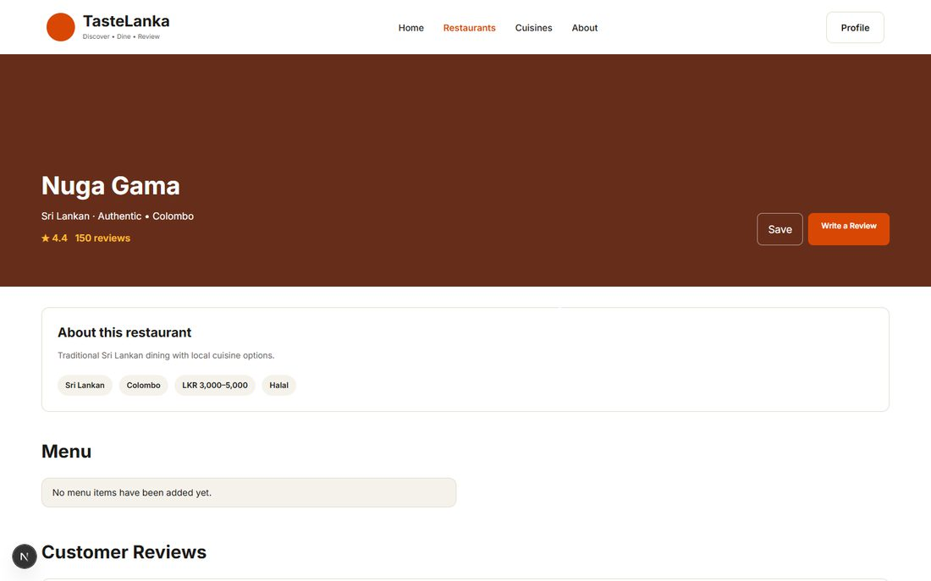
Cycle 1 · EVID-281 · DEF-015 — saved state after reload — source: cycles/evidence/ui/TC-UI-008-saved-state-after-reload.png
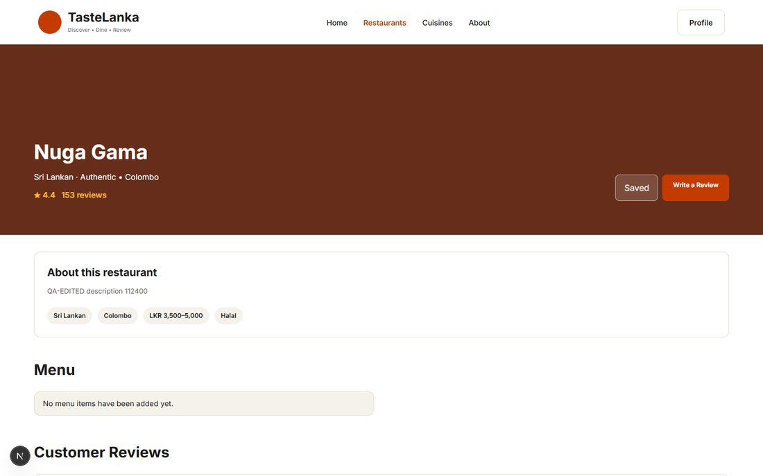
Cycle 2 · C2-EVID-323 · DEF-015 — saved state after reload — source: cycle 2/evidence/ui/TC-UI-008-saved-state-after-reload.png
DEF-007 — deleting a reviewed restaurant
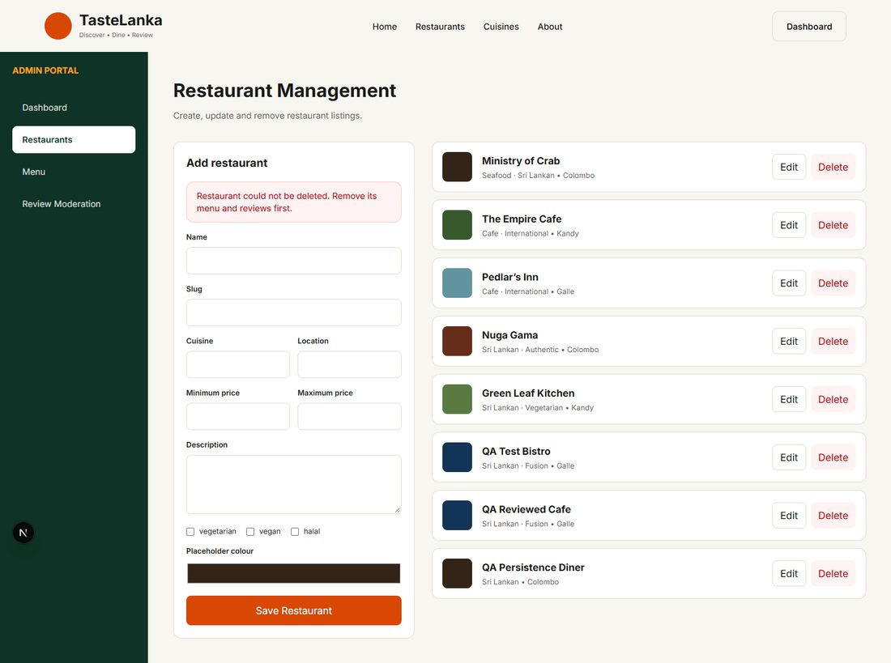
Cycle 1 · EVID-271 · DEF-007 — deleting a reviewed restaurant — source: cycles/evidence/ui/TC-ADM-UI-002-delete-restaurant-with-reviews.png
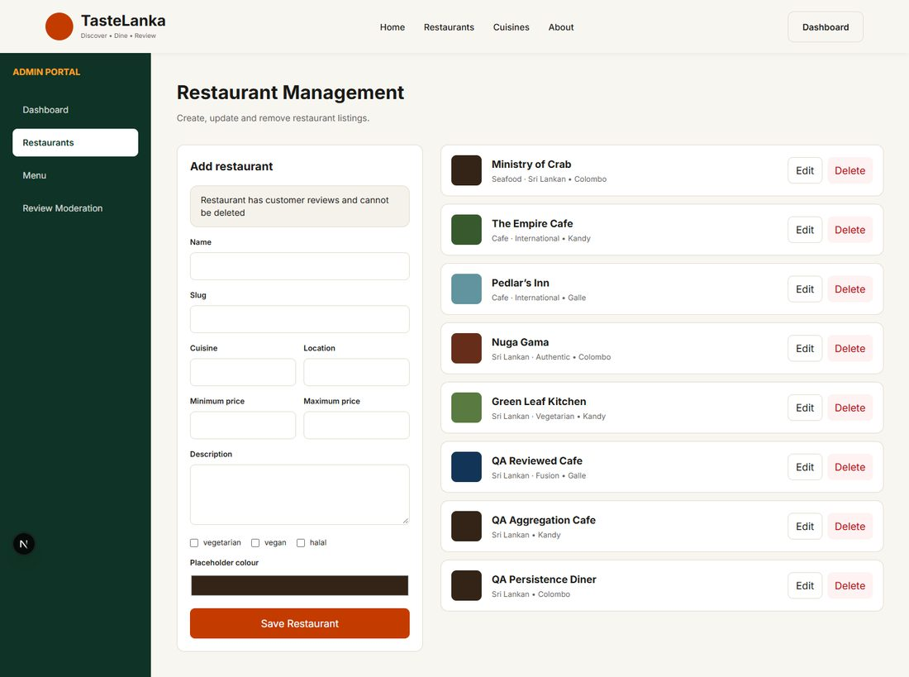
Cycle 2 · C2-EVID-313 · DEF-007 — deleting a reviewed restaurant — source: cycle 2/evidence/ui/TC-ADM-UI-002-delete-restaurant-with-reviews.png
DEF-016 — home page Top Rated
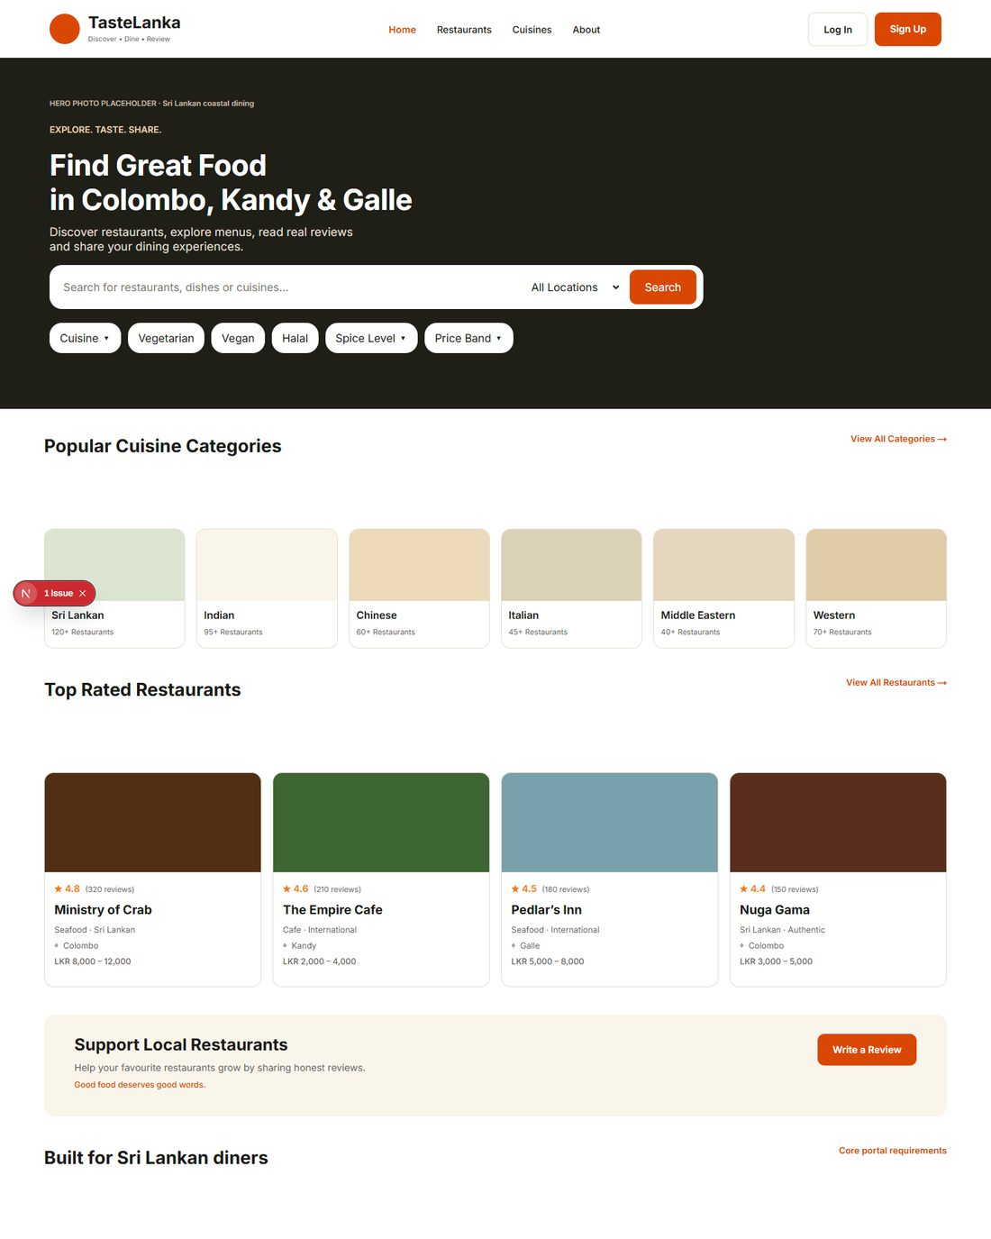
Cycle 1 · EVID-273 · DEF-016 — home page Top Rated — source: cycles/evidence/ui/TC-UI-001-home-desktop.png (top of page shown)
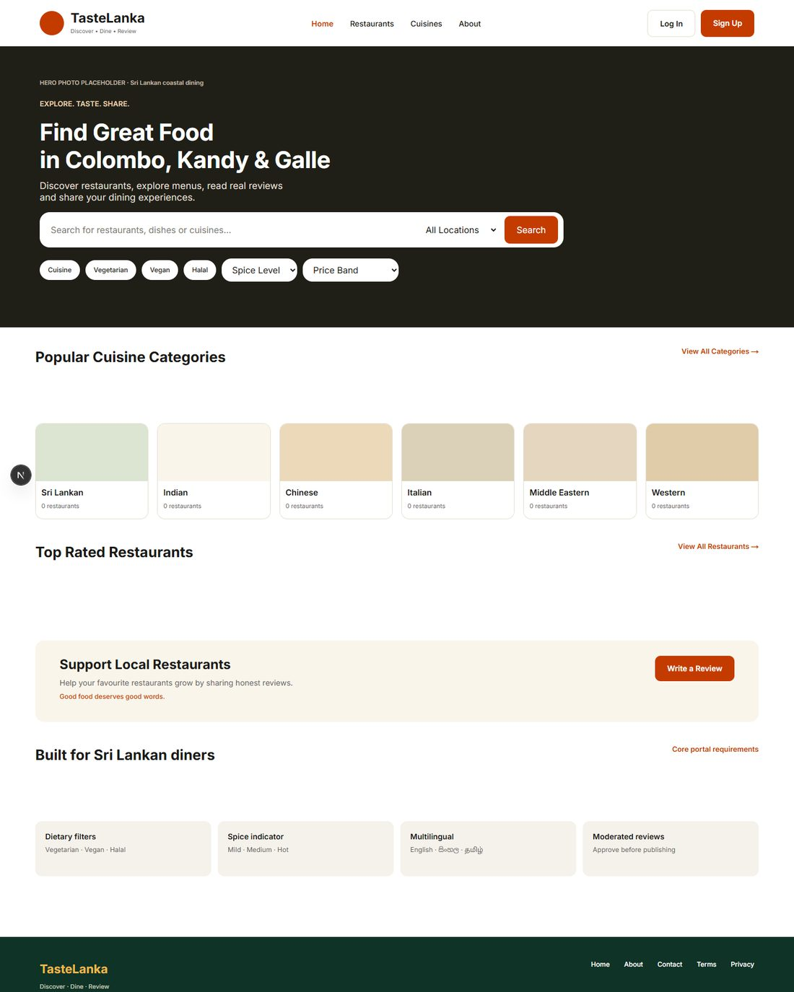
Cycle 2 · C2-EVID-315 · DEF-016 — home page Top Rated — source: cycle 2/evidence/ui/TC-UI-001-home-desktop.png (top of page shown)
DEF-020 — moderation audit details
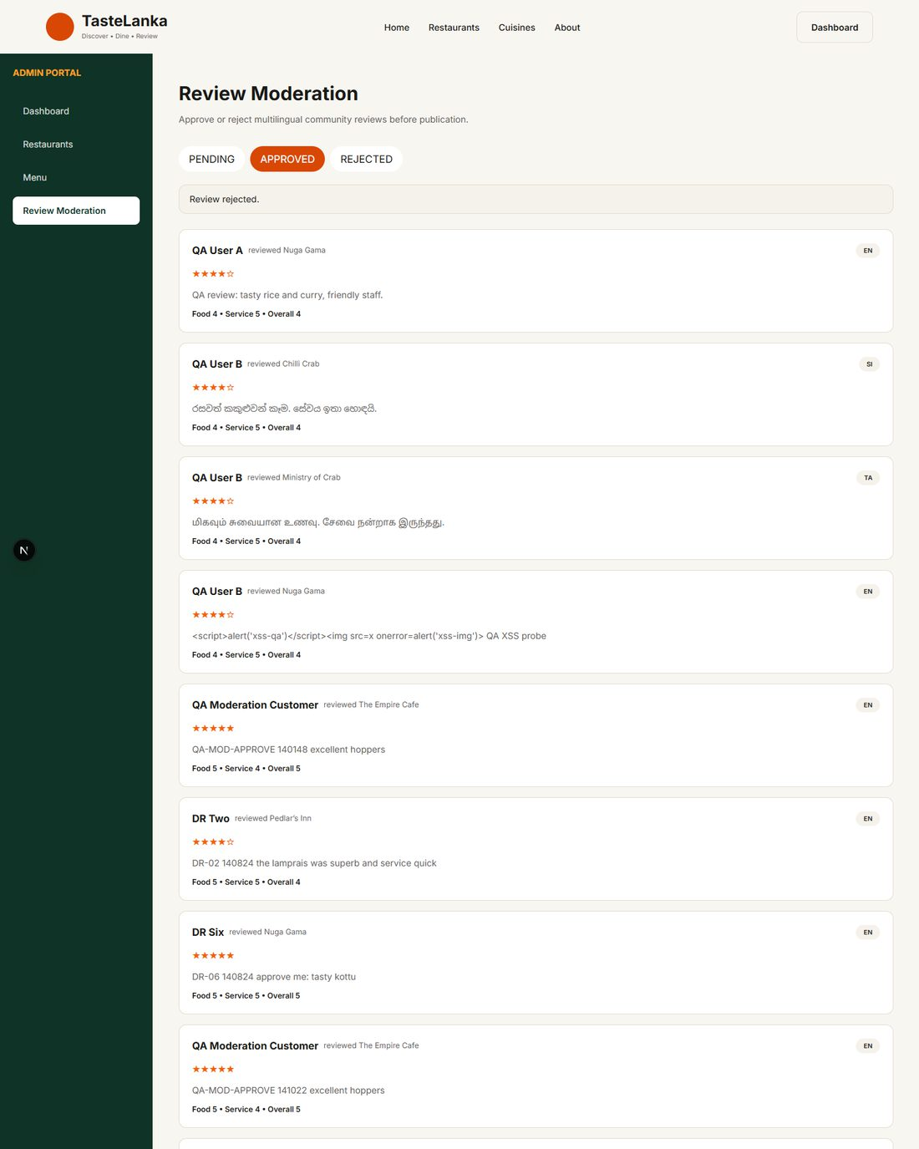
Cycle 1 · EVID-257 · DEF-020 — moderation audit details — source: cycles/evidence/ui/BB-13b-moderation-approved-tab.png (top of page shown)
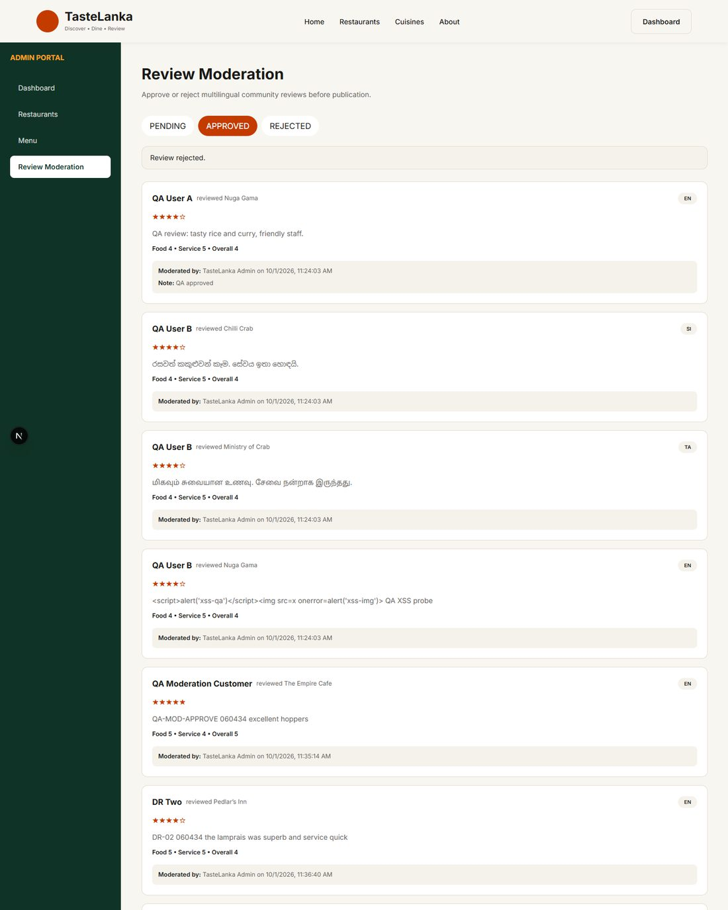
Cycle 2 · C2-EVID-293 · DEF-020 — moderation audit details — source: cycle 2/evidence/ui/BB-13b-moderation-approved-tab.png (top of page shown)
C2-EVID-304 · BB-20a — axe-core results, cycle 2 (DEF-017, DEF-018)
No WCAG 2.1 A/AA violations reported on the 10 scanned pages.

